**BOLSONARO AND THE 2018 ELECTIONS: GUNS ABOVE EVERYTHING, GOD’S VOTES ABOVE EVERYONE.**

Caio Cavalcante dos Santos[1]

**ABSTRACT:** In a polarized Brazil, the great winner of the 2018 elections was Jair Messias Bolsonaro, from the Partido Social Liberal (Social Liberal Party, or PSL), a congressman elected by the state of Rio de Janeiro for years but who has always been ignored by the intellectual elite and the administrative leaders of the country. With more than 57 million votes and a rhetoric that mixes conservatism, punitivism and an attachment to evangelical values, the now President Bolsonaro relied on the support of two categories which are active on the national political process: guns rights supporters and religious evangelicals, which are represented in congress by the “Frente Parlamentar pela Segurança Pública” (Parliamentary Front for Public Security) and the “Frente Parlamentar Evangélica” (Evangelical Parliamentary Front). The argument defended here is that measurers for urban violence such as firearm homicide rate and the evangelical population strongly contributed to the victory of PSL’s candidate. Besides that, we have included into the analysis the homicide rate of black people, who are the majority of the Brazilian population, and a factor which we hope will be in opposition to the political. We have analyzed the data of all 26 states in the country, plus the Federal District.

**Keywords**: Elections; Public Opinion; Electoral Behavior.

**INTRODUCTION**

Which factors led Jair Bolsonaro, a politician who has been renegaded and is seen by many as ludicrous, to an electoral victory in the 2018 Brazilian Presidential Elections? This is the question that will guide this paper, which aims to understand a presidential race which created a great mobilization of Brazilian public opinion as well as the scientific and intellectual class of the country. With more than 47 million votes in the first round of elections, the politician from the Partido Social Liberal (PSL) has had a long career in politics, which for many years was attached to his controversial statements.

Identifying himself with thematic parliamentary fronts such as the Evangelical Parliamentary Front and the Parliamentary Front for Public Security, Bolsonaro has worked on creating in his image the representation of the solution for a political system which has long been in crisis, taking advantage of a tumultuous situation in the country since the June Journeys of 2013, when many people took to the streets in protest for the first time in their lives and that has led to different events such as the Car Wash Operation, the Impeachment of Dilma Rousseff elected by Partido dos Trabalhadores (The Worker’s Party, or PT), the economic crisis and the comeback of structural problems all over the country (RAMOS, 2014, COMPARATO, 2014; BORBA, CARREIRÃO e RIBEIRO, 2016; DELCOURT, 2016; MORETTO, ORTELLADO e SOLANO, 2017; BORGES e VIDIGAL, 2018).

The goal here is to understand this process and to achieve this, this paper has produced a linear regression analysis between the votes of the now President and the rate of homicides by firearm, the evangelical population and it also incorporates into the model the homicide rate of black people in Brazil[2], the majority of the population, which are regularly ignored in the political discourse that considers Brazil as a mixed country, where racism is something secondary and often non-existent.

The results show signs of a causal relation between the rise in the evangelical population in the states and the votes Bolsonaro earned in each of them, whereas various variables related to public security show no sign of a relation between public security and the electoral success of the retired captain of the Brazilian Armed Forces.

Thus, this paper will be divided as follows: the next topic will discuss the political build-up of Bolsonaro and his relation with the deconstruction of various notions and postulates of the recent Brazilian democracy; in a following moment, we will discuss the variable choices, supported by Political Science theories on the impact of black people and evangelicals on the Brazilian election; The final topics of the paper will present the results and analysis of the model, first with an exploratory evaluation of the data, followed by the results of the model and its assumptions. Finally, the final considerations to this discussion will be presented.

**BUILDING A “MYTH”**

In 2010, beyond the presidential race that elected Dilma Rousseff from the Partido dos Trabalhadores (PT), Brazil started to interact more directly with a new type of politician, one which is oblivious to the practices of the known “high clergy”[3] of the national Congress. Jair Messias Bolsonaro is introduced to the average Brazilian through his interviews, which were then considered ludicrous and controversial and which presented a set of characteristics completely different to those of traditional politicians, or at least that is how people started seeing and interpreting him, according to the study of scientists that dealt with qualitative electoral behavior and admirers of a new right wing, forged during this same time period (MESSENBERG, 2017; PINHEIRO-MACHADO e SCALCO, 2018).

Althoug his rhetoric was often linked to a secondary and oftentimes humorous place in entertainment shows such as Custe O que Custar from Rede Bandeirantes de Televisão or Programa SuperPop from Redetv, the rise in internet access in the country helped Bolsonaro access a electoral niche that hadn’t seen themselves represented by national politics in a long time, combined with the budding resentment towards PT’s governments, which started in 2010 as small noises and grew as the years and problems went by, consolidating itself in 2013 with the June Journeys and the scandal brought to light by the operation Car Wash of the Federal Police, shedding light to numerous names which are now linked to what is called “the old politics” in the country (RAMOS, 2014, COMPARATO, 2014; BORBA, CARREIRÃO e RIBEIRO, 2016).

During the 2014 elections, even with Dilma Rousseff’s win, Brazil was already aligning itself to questions and discussions which had seemed obsolete such as conservative topics and cuts and delimitation to moral behaviors, led by the evangelical Parliamentary Front and the phenomenon of the evangelical vote (MARIANO E PIERUCCI, 1992; SIPIERSKI, 1997; PIQUET, 1998; MACHADO, 2002, 2003, 2014; CAMPOS, 2006, 2008, 2010 e 2011; BURITY, 1997, 2001, 2004, 2006, 2013, 2014; FONTELES, 2007 e 2010; ORTIZ, 2001; LUNA, 2014; ORO, 2003, 2006, 2007, 2011; FULKS E RODRIGUES, 2015; SANTOS, 2016), the anti-communism and anti Worker’s Party feelings which wound up associated with the crusade against corruption and opposes the action of political parties, gaining strength in the process that elected that year the most conservative congress in Brazilian history[4], establishing which some scholars consider a cultural war in the country and allowing a certain nostalgia toward the military dictatorship period in Brazil, backed up by a punitivist feeling in national society (DELCOURT, 2016; MORETTO, ORTELLADO e SOLANO, 2017; BORGES e VIDIGAL, 2018).

In a context that is becoming increasingly favorable to radical ideas and tough speeches, Jair Messias Bolsonaro, alongside his three sons, Eduardo Bolsonaro, Flávio Bolsonaro and Carlos Bolsonaro have taken it upon themselves to represent all the narratives that make up the Brazilian “new right”, from the right to agricultural property to anti-environmentalism ideals, from radical conservatism which is borderline fundamentalist to being vehemently against any type of lobying (eu n consegui pensar numa tradução melhor pra fisiologismo politico foi mal), much like various political leaders around the world, which are considered as right wing populists or neo-populists: always defending patriotism, the creation of a public enemy and claiming to be able to bring back a country that since 2015 has sunk into social, economic and political crises (LOWY, 2015; MORETTO, ORTELLADO e SOLANO, 2017), it is not by chance that, since Donald Trump’s win in 2016, members of the Bolsonaro family seek to associate themselves with the way the north American President does politics.

Bolsonaro arrived in 2018 with great notoriety and voting intentions, even though his win was treated as something Utopic by various specialists in Brazil, little by little the simple aesthetics of his videos, his tough way of addressing the public and catch phrases began to have an effect. Bolsonaro tore through preconceived notions of how elections work in Brazil according to the literature on elections and the national political science started to see its core affirmations being abandoned by the electoral phenomenon of Bolsonaro. Political Science used to see Brazilian democracy as having moderately consolidated insitutions, which could prevent the emergence of an outsider in the electoral dispute, Mancuso (2014) focuses on summing up the Brazilian research agenda about the electoral cycle, other works such as Bruno Speck and Mauricio Campos (2014) or André Borges (2015) focus in aspects that, up until that time period, made complete sense in our electoral reality: resources were important for political campaigns, the impact of television advertisement and its timing thought the day, these aspects have always been a part of the political game and were considered key elements for winning (BENDER and NAKAGUMA, 2010). This paradigm has, however, been broken by Jair Messias Bolsonaro[5].

In the beginning of the electoral year, Bolsonaro was a candidate without a party, becoming a member of the Partido Social Liberal (PSL) only in March 2018, with a political career of almost 30 years, the retired captain of the Brazilian army, was used to switching parties constantly during his life as a congressman. Besides that, the distance between him and his former colleagues in congress never yielded relevant appointments to positions of political leadership, which meant that he had a smaller share of the radio and TV time during the electoral race[6], his coalitions was composed of a small number of parties, he was left with six seconds of each hour allocated to political campaigns and one insertion each six days. while other candidates such as Geraldo Alckimin or Fernando Haddad had this space daily, followin the rules of the electoral Supreme Court (TSE).

PSL’s candidate resorted to the internet, where he dominated the rhetoric of vital questions and had a legion of fans. This was enough for him to win the first round with over 49 million votes, reaching the second round and beating PT’s candidate, Fernando Haddad, with 57 million voters opting to elect a self-titled outsider, nicknamed by many as “the Myth”. Many scholars have been showing the emergence of such politicians all over the globe (WAISBORD, 2013; WODAK, 2015; HARTLEB, 2015; SERAZIO, 2016).

If Jair Bolsonaro will be successful in leading Brazilian national politics, we cannot say for sure, what we can do is analyze which facots lead PSL’s candidate to win. In the following section, I will discuss the variables used in the regression model brought by this study, which has as its main factors to be tested urban violence and the strength of the evangelical vote.

**FIREARMS ABOVE EVERYTHING AND GOD’S VOTE ABOVE EVERYONE**

The choice of variables to be tested cannot ignore the fact that electoral studies are always complex, what this paper aims is to expand the discussion and find empirical basis to pin point which factors led Jair Bolsonaro to an almost unexpected victory. The following table points the variables which will be used in the model, whose dependent variable is Jair Bolsonaro’s votes in the first round, measured state by state in Brazil. The decision in the data management to turn the absolute number of votes into a logarithm was made in order to not overestimate the results with high numbers, and the decision to use the data relative to the votes in the first round was because the high number of votes for Bolsonaro on the first round, when there were 12 other options, point to a significant electorate choosing the retired captain was their president.

**Table 1 – model variables.**

|  |  |
| --- | --- |
| Independent variables | Dependent variable |
| Logarithm of the evangelical population of each state in Brazil;  Homicide by firearm rate of each state in Brazil;  Homicide rate of black people of each state in Brazil | Logarithm of Jair Messias Bolsonaro’s vote on the first round in each state of Brazil |

**Formulated by the author.**

As for the independent variables, we have the rate of homicide by firearms measured in each federal unit of the country, alongside the homicide rate of black people, also measured in each federal unit, creating a duo of public security issues. Besides that, the gross number of the evangelical population in each state of the country, using data from the demographic sense of IBGE of 2010, but we understand that the trend for this particular sector is to grow, the lack of more recent data means that the results of this model should not be disconsidered. In this section, I will discuss each variable as well as the empirical and theoretical arguments used as the foundation for this model.

Although he showed up to almost no debate during the campaign, due to the attack he suffered on the 6th of September of 2018, when a knife was pushed into his abdomen[7], Jair Bolsonaro did present a governmental program which contained the guidelines to his administration.

The retired captain of the Brazilian armed forces has always been associated with the public security agenda and he has become known for his speeches where he advocates in favor of guns rights, defending less state control over the issue with the intention of making it easier for people to defend themselves. He is also known for being favorable towards a greater appreciation of the military police. It is unsurprising then that he dedicates a large number of pages of his “Phoenix Plan”, his government plan registered alongside the electoral supreme court, these issues. On the other hand, one of the biggest trademarks of his political speech is his resistance to addressing racial issues – he was seen numerous times wearing a tee shirt with the saying “my color is Brazil”, a phrase which alludes to both the anti worker’s party feeling and the revulsion towards the color red, as well as to the fact that Bolsonaro and his supporters don’t consider racism as a real in Brazil.

Nonetheless, there is evidence and studies which indicate the opposite of what Bolsonaro and his supporters preach and believe: considering the new reality of Brazil in the beginning of the XXI century, where there has been a substantive rise in purchasing power[8], the perception of other values and variables in research and analyses, such as race has started to be needed and relevant, not in opposition to economic and more positivist variables but as a complement to those, aiming to better explain complex social facts. According to IBGE data, in 2014 54% of the national population was composed of blacks and mixed race individuals, which means that most of the country’s population belong to a social group that faces hardships which cannot simply be associated or explained by one’s financial situation.

In May 2015 a Parliamentary Inquiry Commission (CPI) was established on the Senate to look into the homicide of young Brazilians, one year later the findings of such Commission confirmed that the high number of homicides was linked to two specific variables: race and class. The most alarming finding of this investigation is that every 23 minutes a young black man is murdered in Brazil. The report also found that the most affected by violence are those who are both black and poor, violence also disproportionately affects black men and women who are on different economic levels. Beyond violence and lack of security, over half of the brazilian population suffers with unequal pay, unemployment, low quality of life and lack of access to basic and high level education[9], with black women being the ones who suffer the most.

The Brazilian Institute of Geography and Statistics (IBGE) uses the term “black” to encompass those who self declare as black or “brown” (“pardos”). In 2014, IBGE found that 54% of the Brazilian population declared themselves in that way. The reality in the political arena although is very different. Data from the electoral Supreme Court (TSE) and the journalistic project “Congresso em foco”[10] found that only 20% as of today are non-white, which shows a complete imbalance between how the population sees themselves and how they choose their leaders. Dawson (1994) observes that the historical and institutional discrimination against blacks lead the individuals to associate their life opportunities to the life of the group:

*Some blacks use the group’s interest as a Proxy for their individual interest when manking political choices (DAWSON, 1994).*

Non-white people face more hardships in order to rise in the political arena, in a scenario of great competition for valuable resources within the electoral sphere, this is the result of the research of Campos e Machado (2015) that sought to understand empirically the distance between voter and politician, according to the authors, there seems to be a pernicious interaction between the sociological dynamics of racial discrimination in brazil and the inner workings of our own electoral system (CAMPOS E MACHADO, 2015). The role of resources (or lack thereof) within the gap of legislative representation of the Brazilian black population shows that there is a numerical advantage for the white elites, and that has to do with the fact that these elites hold most of the resources needed for growing in the political arena, which maintains the resource barrier for other, non white populations (BUENO AND DUNNING, 2017). As these numbers cannot be ignored, there is a clear need for public policies that protect these people and it is to be expected that the distance Bolsonaro puts between himself and this aspect of a problem that he treats with such ease could be a problem for his electoral results.

Member of the Parliamentary Front for Public Security, Jair Bolsonaro has always been one of the most quoted politicians in this topic (CARVALHO, 2017), insde the symbolism of the finger-guns, lies a politician heavily associated with pro-gun movements in Brazil, the Viva Brasil movment, which associates the pro-gun ideals with the right to self-defense, this type of rhetoric has consolidated itself because the population believes that we have seen an increase of violence in the past years, specially in urban areas[11]. Unlike the other variable, it is expected here that a politician so closely linked to the pro-gun movement will experience a rise in votes on the states where death by firearms is more common.

On the week before the first round of the presidential elections, Jair Bolsonaro publicly received the support of Edir Macedo, leader of the church “Universal do Reino de Deus”, the second most common evangelical denomination in the country. Another religious leader, Father Silas Malafaia, who represents “Assembléia de Deus” (another popular evangelical denomination in Brazil) supported Bolsonaro all year. The relationship between Bolsonaro and the evangelicals goes back some time, even thought he is baptized catholic, the now president has always sided with the evangelical Parliamentary Front in their political disputes in Congress. Politicians and evangelical leaders have taken it upon themselves to fight against the decriminalization of abortion, of drug consumption, of the civil union of homosexuals. The affirmation of christian values, traditional concepts of family in combination with the maintenance of religious freedom are constant themes on their agenda (WARKEN, 2014). The economic interest in maintaining and expanding concessions of radio and television stations and mobilizing resources to their own organizations are also part of their agenda (FRESTON, 1993).

This rapprochement doesn’t seem to be random, in 1980 the evangelicals were 143 thousand brazilians, in about fifty years the number went to 1.074.857 brazilians. During the re-democratization period (19991-2010) and throughout the expansion of democratic competition, the evangelicals continued to grow, reaching 42 million of brazilians in 2010.

The population data, although important are simply the first mechanism needed to understand the strength of the evangelicals within the brazilian states. In regards to the political aspect, the evangelicals have shown electoral success, great capacity for mobilization within their churches, in combination with great media insertion, constant presence on television channels and the resources to produce decent electoral campaigns have led to more and more electoral success (BURITY AND MACHADO, 2014), one of Silas Malafaia’s oldest dream is the election of a politician that represented evangelical values in Brazil (CAMPOS, 2006). In the following section we well investigate if the evangelical population has any influence in the realization of this political dream for some, and nightmare for others.

**RESULTS**

Firstly, the analysis done in this paper observed some basic descriptive statistics of the variables used in the model. The dependent variable (logarithm version of the votes Jair Bolsonaro gained in the first round), as shown on the table exhibits an average of 1,85, which means that the standard deviation would be, on average, 0,49. The use of a logarithm version of the votes serves the purpose of avoiding an overestimation of the results, because this variable was originally measured in absolute number. It also guarantees that this variable will have a normal distribution. The independent variables used in the model such as rate of homicide by firearm, rate of homicide of black people and the evangelical population by state, this date is also listed on the table below. For the homicide rate of black people, we found an average of 43,79 and a standard deviation of 3,09.

The rate of homicide by firearms has an average of 25,66 and an standard deviation of, on average, 2,25. As for the evangelical population variable it was, at first, described using absolute numbers but later on, I opted for transforming it into a logarithm in order to keep the model linear. Another interesting point to be mentioned in this initial analysis is how these independent variables behave when associated to our dependent variable.

**Table 1 - Descriptive analysis of the variables**

|  |  |  |  |  |  |  |
| --- | --- | --- | --- | --- | --- | --- |
| Variable | N | Average | Standard Deviation | Median | Minimum | Maximum |
| Votes for Bolsonaro | 27 | 1.85 | 0.49 | 0.94 | 0.17 | 12.38 |
| Rate of black homicides | 27 | 43.79 | 3.09 | 42.30 | 13.50 | 79.00 |
| Rate of homicides by firearms | 27 | 25.66 | 2.25 | 24.16 | 6.08 | 55.57 |
| Evangelical Population | 27 | 9937853.00 | 387511.12 | 1085480.00 | 136480.00 | 9937853.00 |

**Sources: Database formulated by the author with data from the 2010 census of the IBGE; Violence Atlas from the Institute of Applied Economics Studies; and Electoral Supreme Court (TSE).**

In regards to the homicide rate of black people and the rate of homicides by firearm it was not possible to see a clear association pattern between the variables, even if in the first case there are visual indications of a negative relationship between them, because as the homicide rate grows the logarithm of Bolsonaro’s votes lowers, however this will actually only be tested in the regression model, graphics 1 and 2 were built to help visualize this relation between homicide rate and the logarithm of Jair Bolsonaro’s votes in the first round.

**Graphic 1 – Scatter plot of the variables homicide rate of black people x logarithm of Jair Bolsonaro’s votes in the first round.**

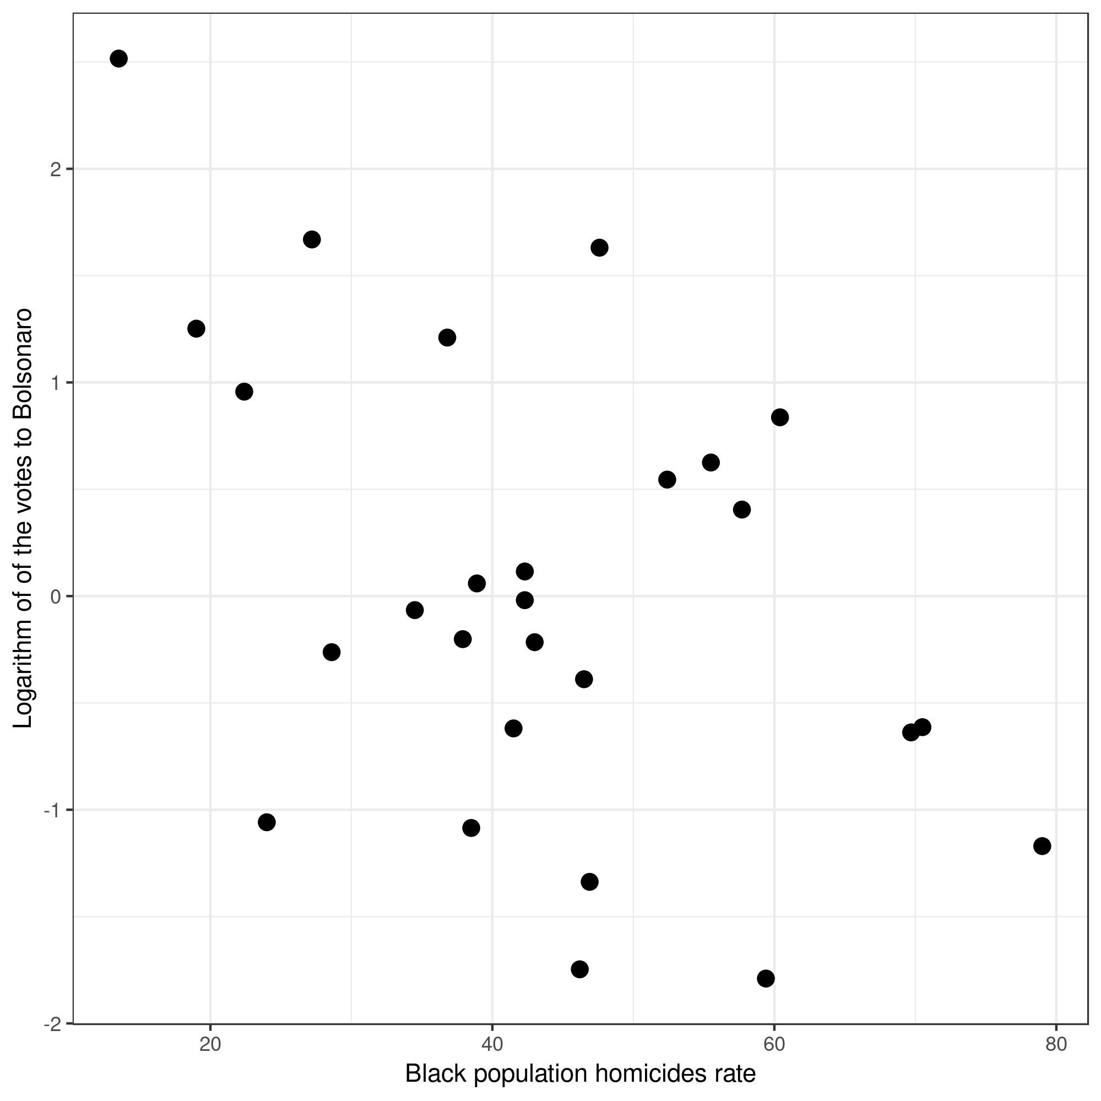

**Sources: Database formulated by the author with data from the 2010 census of the IBGE; Violence Atlas from the Institute of Applied Economics Studies; and Electoral Supreme Court (TSE).**

**Graphic 2 – Scatter plot of the variables rate of homicide by firearm x logarithm of Jair Bolsonaro’s votes in the first round.**

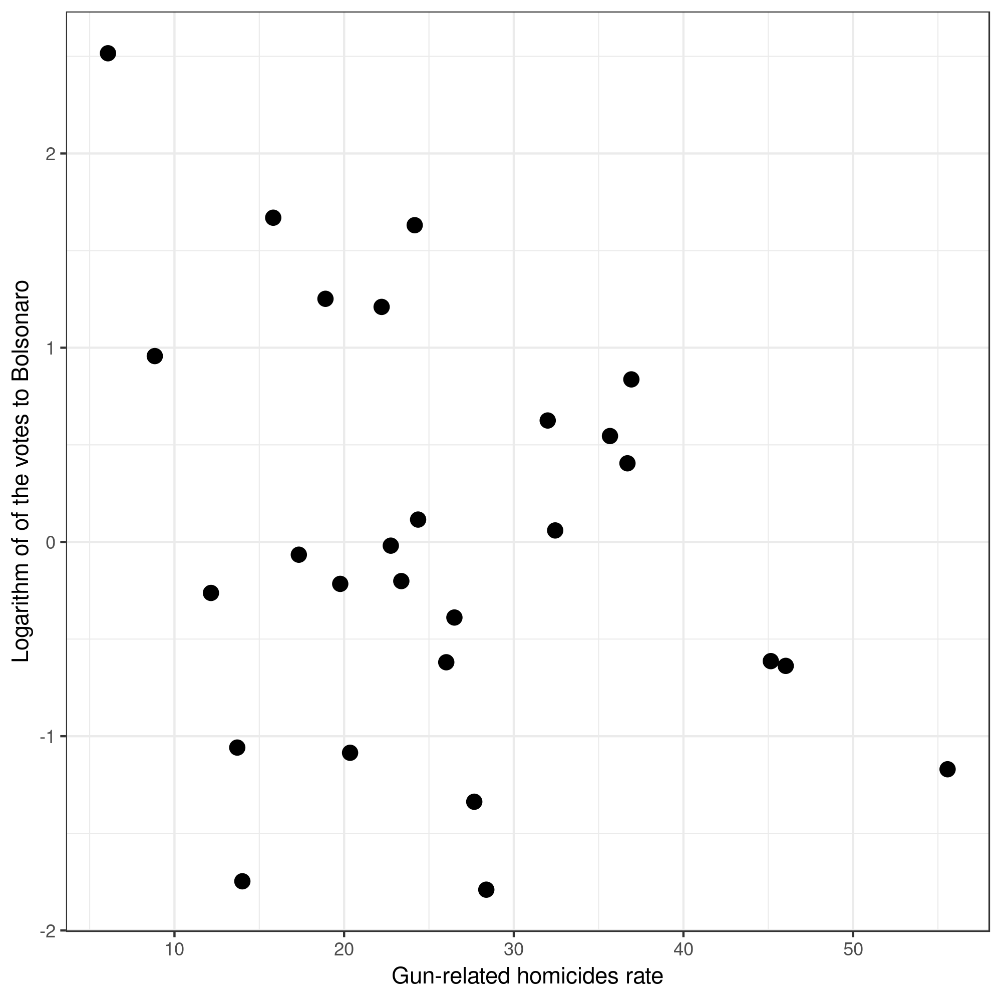

**Sources: Database formulated by the author with data from the 2010 census of the IBGE; Violence Atlas from the Institute of Applied Economics Studies; and Electoral Supreme Court (TSE).**

As for the evangelical population variable, this relation presented itself differently, as graph 3 presents a strong association between the growth of the evangelical population and the rise in votes of the now president Jair Bolsonaro. Visually, we have a graph that crosses these two variables in their logarithmic versions, establishing a linear relation between them. This previous information allows us to foresee what the model will tell us.

**Graphic 3 – Scatter plot of the variables logarithm of the evangelical population x logarithm of Jair Bolsonaro’s votes in the first round.**

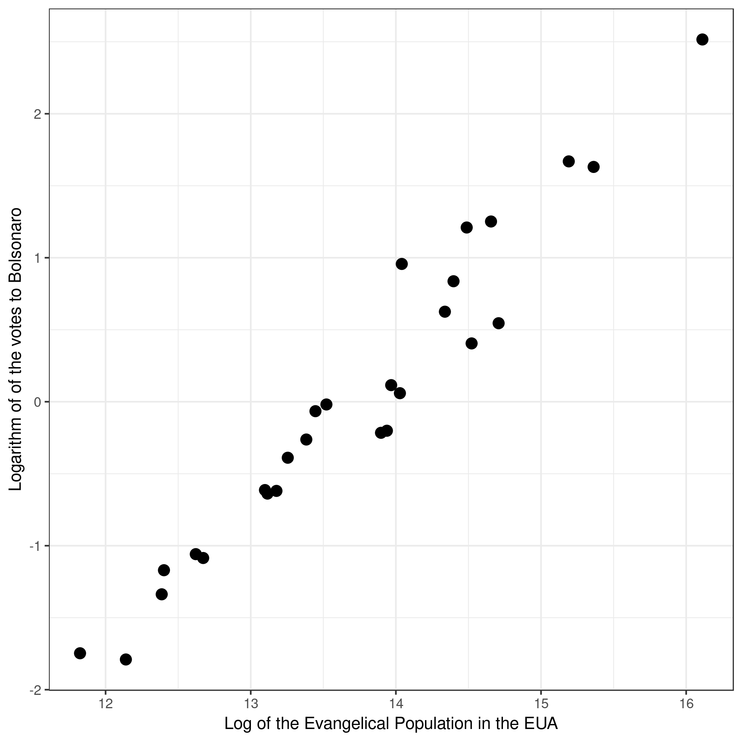

**Sources: Database formulated by the author with data from the 2010 census of the IBGE; Violence Atlas from the Institute of Applied Economics Studies; and Electoral Supreme Court (TSE).**

Having the logarithm of Jair Bolsonaro’s votes during the first round as our dependent variable, our model uses three explanatory variables: the homicide rate of black people, the rate of homicides by firearms and the evangelical population, all measured in each federative unit of the country.

The first relevant information we can take away from the model comes from the estimated value of the effects of how much one variable can, on average, affect the dependent variable. After that, we will be able to tell how precise this effect is throughout the sample. In order to do that we will watch the standard deviation which indicates the scale of variations of those relations, and here we have the trio of measures to be analyzed in this model, it will be needed to watch the p-value of each independent variable where the objectivity (n sei como traduzir isso direito) of the variable is proven when its p-value is lower than 0,05.

As a starting point, the regression model shows us a negative relation between the homicide rate of black people and the rate of homicides by firearm and our dependent variable. This relation could be described as inversely proportional, where the rise in homicides by firearms and the rise in the homicides of black people lowered the votes for Jair Bolsonaro in the first round however, this estimated value is low in both cases as is shown on table 2, besides the standard deviation value in relation to the estimated value is too great in both cases, which influences the value of each of the variables p-values, which are much higher than the cut-off value of 0,05. Therefore, both of these variables are not statistically relevant, which means that they do not offer us objective information that would help predict the number of votes for Bolsonaro in the first round.

However, the results of the independent variable “evangelical population” in its logarithmic version has an estimated average effect of 0,97 which when compared to a standard deviation of 0,055 there is a big difference between the two values, with the standard deviation being much lower than the estimated average effect of the variable. This explains why the p-value of this variable is very low ate 0,000000000000000852, much lower than the cut-off value of 0,05 and it indicates that the relation between the evangelical population and the votes for Jair Bolsonaro in the first round is consistent, significant and precise. Based on this data we can say that there is a strong causal relation between the growth of evangelicals within a state and the number of votes Bolsonaro obtained on that state. Lastly, the value of the Multiple R-Squared indicates that this model explains 95% of the variation of Jair Bolsonaro’s votes among the federal units of Brazil, having the evangelical population as its explainable variable.

**Table 2 – values of the regression model.**

|  |  |  |  |  |  |
| --- | --- | --- | --- | --- | --- |
| Coefficients: |  |  |  |  |  |
|  | Estimate | Std. Error | T value | Pr(>|t|) |  |
| (Intercept) | -13.115226 | 0.852568 | -15.383 | 1.35e-13* |  |
| rate_black_homicide | -0.004951 | 0.008628 | -0.574 | 0.572 |  |
| rate_homicide_firearms | -0.001532 | 0.011191 | -0.137 | 0.892 |  |
| log_evangelical_pop | 0.975579 | 0.055697 | 17.516 | 8.52e-15* |  |
| Residual standard error: 0.2565 on 23 degrees of freedom  Multiple R-squared: 0.9504, Adjusted R-squared: 0.9439 F-statistic: 146.7 on 3 and 23 DF, p-value: 3.885e-15 |  |  |  |  |  |

**Sources: Database formulated by the author with data from the 2010 census of the IBGE; Violence Atlas from the Institute of Applied Economics Studies; and Electoral Supreme Court (TSE).**

**MODEL ASSUMPTIONS: DEALING WITH HETEROSCEDASTICITY**

We start the observation os the model assumptions with the analysis of the residue via their distribution. The following graphic was created to show if the residues present themselves normally and with an average of zero. As it can be seen, therefore, there is a normalization of the residues of the model. However, the multicolinearity test done using the variance inflation factor (FIV), shows high values for the two variables related to homicides: the homicide rate of black people has a FIV of 7.58 whereas the rate of homicides by firearms has a FIV of 6.79. Multicolinearity is a recurring issue of regression models, where the independent variables present linear relations almost exact. As for the logarithm of the evangelical population variable, it has a lower FIV of 1.33, and is lower than the other two variables, as it can be seen on table 3.

**Graphic 4 – Histogram of residues distribution.**

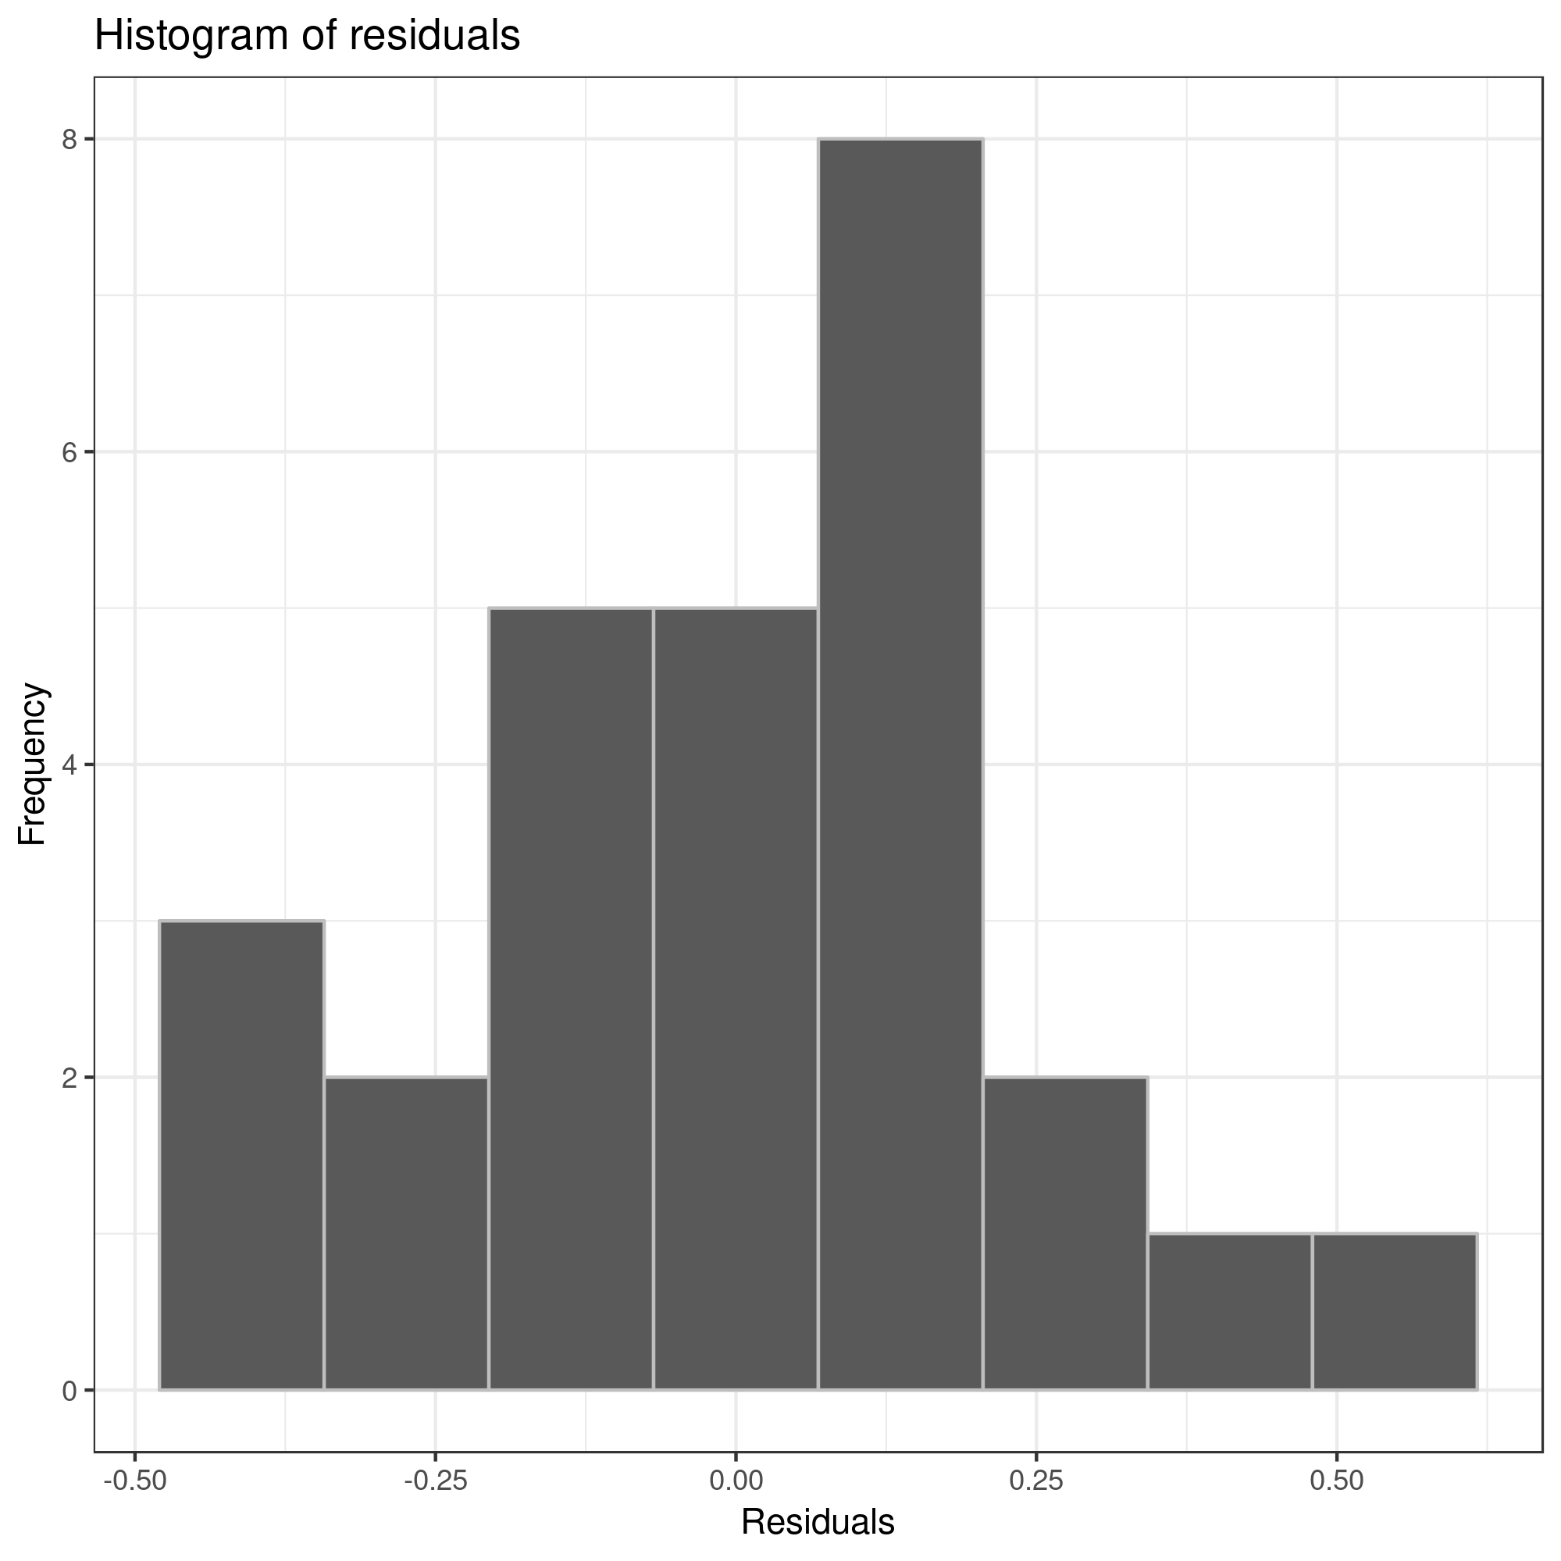

**Sources: Datebase formulated by the author with data from the 2010 census of the IBGE; Violence Atlas from the Institute of Applied Economics Studies; and Electoral Supreme Court (TSE).**

Another problem identified here was the indications of heteroscedasticity in the model, which happens when the residues in some cases show indications of correlating to the independent variables. Graph number 5 shows us that within the model some values are far above the zero line, which represents a inconsistent variation in the analyzed cases.

**Graphic 5 – Scatter plot of the model residues.**

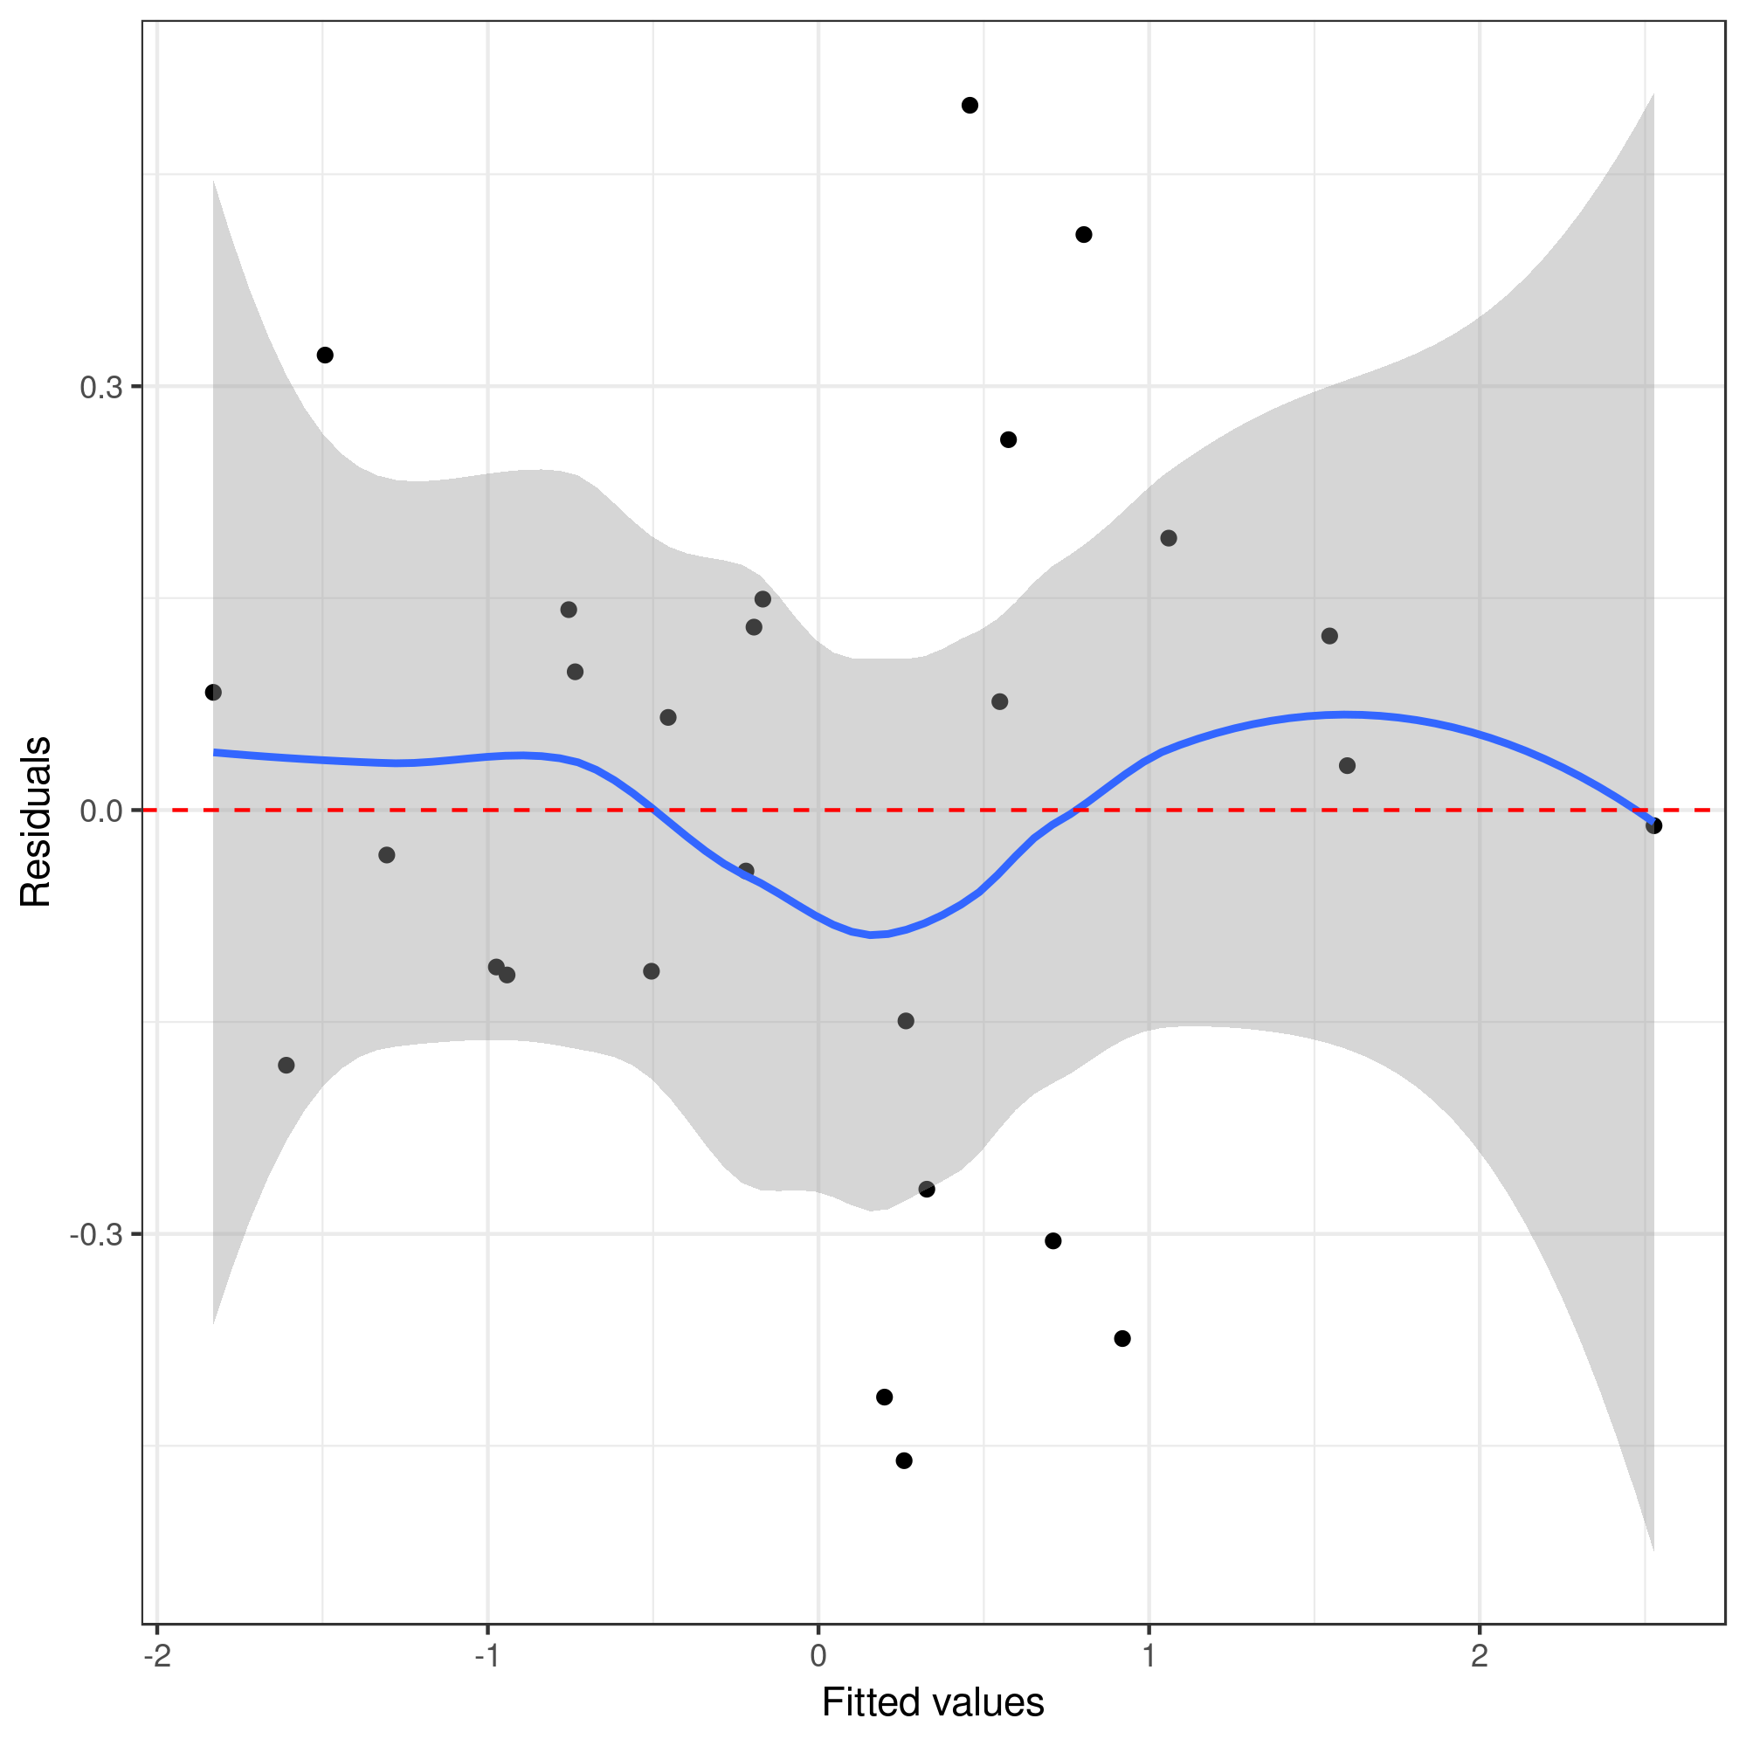

**Sources: Database formulated by the author with data from the 2010 census of the IBGE; Violence Atlas from the Institute of Applied Economics Studies; and Electoral Supreme Court (TSE).**

One of the known effects of heteroscedasticity is creating biased estimates for the standard deviation of each variable (BRUSCH e PAGAN, 1979; KOENKER, 1981). In order to solve this problem I used a new estimator for the standard errors via the Huber-White tests which accommodate the observations which are far above the zero line in graph 5, this estimator fixes inconsistencies on the estimates of standard errors of the coefficients, which are created by the presence of heteroscedasticity (HUBBER, 1967; WHITE, 1980). These observations end up working as a species of certain observations which had a prediction error that was too big and it ends up estimating a standard error for the coefficients, however, when we used the aforementioned correction, these residual cases are treated correctly according to the model assumptions.

To sum it up, the residues have shown a normal distribution but the model has shown some heteroscedasticity issues, which were fixed using the Hubber-White estimator, as we can see on table 3. Besides that, the homicide related variables (rate of homicide by firearms and homicide rate of black people) seem to have shown indications of multicollinearity, whereas the variable logarithm of evangelical population doesn’t show strong indications of this issue. I believe that one of the reason for these issues comes from the need to add othe variables in the future which could couple up with the strong presence of evangelicals on the brazilian states which voted more for PSL’s candidate, Jair Bolsonaro. The results as shown are significant and point to a key role played by the evangelicals in the 2018 brazilian presidential race but I understand that the model needs more support and some fine-tuning in the future in order to better its causal explanation power.

**Table 3 – Hubber-White estimator to fix issues caused by heteroscedasticity.**

|  |
| --- |
| **t test of coefficients:** |
| **Estimate Std. Error t value Pr(>|t|)** |
| **(Intercept) -13.1152259 0.6739656 -19.4598 8.776e-16 \*** |
| **tx_hom_negro -0.0049509 0.0086899 -0.5697 0.5744** |
| **tx_hom_arma -0.0015321 0.0126207 -0.1214 0.9044** |
| **log_pevangelica 0.9755786 0.0441170 22.1134 < 2.2e-16 \*** |
| **Signif. codes: 0 ‘*’ 0.001 ‘*’ 0.01 ‘’ 0.05 ‘.’ 0.1 ‘ ’ 1** |

**Sources: Datebase formulated by the author with data from the 2010 census of the IBGE; Violence Atlas from the Institute of Applied Economics Studies; and Electoral Supreme Court (TSE).**

**FINAL CONSIDERATIONS**

The 2018 elections were, perhaps, the most important event in the past years, rising plenty of important questions which can be researched by brazilian Social Science as well as brazilianists. The fact remains that we are living a new phase of brazilian politics that needs to be studied and understood by theory and empirical works that exist in dialogue with the social reality they try to explain. People’s answer at the ballot box was pointed and demythologized plenty of postulates of our recent history. Even though Jair Bolsonaro has had a career in politics, was chosen as the solution to “all that is there”, as he said so himself, even though there are numerous previous works that pointed to this conservative, populist, evangelical, pro-guns current, the surprise among many scholars was proven during the second semester of 2018.

The present paper had set off with the intention of finding explanations and reasons to understand the political phenomenon that is Bolsonaro, who went from a mostly forgotten politician to president of the biggest country in South America. The model conceived here had as its dependent variable the votes cast for PSL’s candidate in the first round of the presidential election and as independent variables the homicide rate of black people, the rate of homicides by firearm and the evangelical population in the 27 federal units of Brazil.

The model has shown that although the homicide rates have a negative relation they didn’t present enough statistical relevance to be considered important, whereas the evangelical population variable presented strong indications of a causal relation with the votes for Jair Bolsonaro. When we take into account the aforementioned works, when it comes to political strenght of the evangelical population, it is very reasonable to link the electoral success of the now President in 2018 with the prevalence of a group that organizes itself politically since the beginning of the XX century (ALVES, 1982; PIERUCCI, 1993; FRESTON, 1994; MENDONÇA, 2008).

Nonetheless, I believe that it is important to add other variables that might help explain even more the results of an electoral race that will not soon be forgotten in Brazil, such as estimators of anti-party feelings, anti-PT feelings (considering that for a large part of the year the former president Luiz Inácio Lula da Silva was in first place in all the predictions) and dissatisfaction with democracy might all help explain Bolsonaro’s win, alongside the evangelical populaiton variable in a future paper. That being said, what the results obtained here show is that as the evangelical population grows in the country, so does the votes for Jair Bolsonaro.

BIBLIOGRAPHY

BORGES, André; VIDIGAL, Robert. Do lulismo ao antipetismo? Polarização, partidarismo e voto nas eleições presidenciais brasileiras. **Opinião Pública**, v. 24, n. 1, p. 53-89, 2018.

BREUSCH, Trevor S.; PAGAN, Adrian R. A simple test for heteroscedasticity and random coefficient variation. **Econometrica: Journal of the Econometric Society**, p. 1287-1294, 1979.

BUENO, NATÁLIA; DUNNING, THAD. **Race, resources, and representation Evidence from Brazilian Politicians**, World Politics 69, n 2. 2017.

BURITY, Joanildo A. **Religião e política na fronteira: desinstitucionalização e deslocamento numa relação historicamente polêmica**. Revista de estudos da religião, v. 4, n. 1, p. 27-45, 2001.

________________. **Religião, voto e instituições políticas: notas sobre os evangélicos nas eleições de 2002. Os votos de Deus. Evangélicos, política e eleições no Brasil.** Recife: Fundação Joaquim Nabuco, Ed. Massangana, p. 173-213, 2006.

________________ **Cultura e identidade no campo religioso.** Estudos Sociedade e Agricultura, 2013.

________________. **Trajetórias da religião e da modernidade: a narrativa histórica de uma objeção**. Estudos de Sociologia, v. 1, n. 13, p. 19-48, 2014.

BURITY, Joanildo; CAMPOS MACHADO, Maria das Dores. **A Ascenção Política dos Pentecostais no Brasil na Avaliação de Líderes Religiosos.** Dados – Revista de Ciências Sociais, Rio de Janeiro, vol. 57, n°3, 2014. PP 601-631.

CAMPOS, Leonildo Silveira. **O Projeto Político de ‘Governo do Justo’: Os Recuos e Avanços dos Evangélicos nas Eleições de 2006 e 2010 para a Câmara Federal.** Debates do NER, v. 2, n. 18, p. 39-82, 2010.

CAMPOS, Leonildo Silveira. **Os Mapas, Atores e Números da Diversidade Religiosa Cristã Brasileira: Católicos e Evangélicos entre 1940 e 2007**. Revista de Estudos da Religião, p. 9-47, 2008.

CAMPOS, Leonildo Silveira. **Os políticos de Cristo – uma análise do comportamento político de protestantes históricos e pentecostais no Brasil.** In BURITY, Joanildo; CAMPOS MACHADO, Maria das Dores (Org.). **Os votos de Deus: Evangélicos, política e eleições no Brasil.** Recife: Fundação Joaquim Nabuco, ed. Massangana, 2006.

CAMPOS, Leonildo Silveira. **Pentecostalismo e Protestantismo" Histórico" no Brasil: um século de conflitos, assimilação e mudanças/Pentecostalism and" Historical" Protestantism in Brazil: one century of conflicts, assimilation and changes**. Horizonte, v. 9, n. 22, p. 504, 2011.

CAMPOS, Luiz Augusto; MACHADO, Carlos Augusto Mello. A cor dos eleitos: determinantes da sub-representação política dos não brancos no Brasil. **Revista Brasileira de Ciência Política**, v. 16, p. 121, 2015.

CERQUEIRA, Daniel Coordenador et al. Atlas da violência 2018. 2018.

COMPARATO, Bruno Konder. Uma Direita Radical no Brasil. **Comunicação apresentada no IX Encontro da ABCP, Brasília/DF**, 2014.

DAWSON, Michael C. Behind the mule. **Race and Class in African American Politics. Princeton, NJ: Princeton University Press**, 1994.

DELCOURT, Laurent. Um TeaParty tropical: a ascensão de uma “nova direita” no Brasil. **Lutas Sociais**, v. 20, n. 36, p. 126-139, 2016.

ELEITORAL, Tribunal Superior. Repositório de dados eleitorais. **Tribunal Superior Eleitoral**, 2014.

FRESTON, P. **Protestantes e política no Brasil: da constituinte ao impeachment**. Tese (Doutorado em Ciências Sociais) - Universidade Estadual de Campinas. Campinas, 1993.

FONSECA, Alexandre Brasil. **Evangélicos e mídia no Brasil**. Editora Universitária São Francisco, 2003.

FONTELES, H. A. **Programa show da fé: um retrato da construção midiática da  
imagem religiosa evangélica**. São Paulo, 2007.

FONTELES, Heinrich. **A ascensão da mídia evangélica: pelo uso do tripé político, econômico e tecnológico**. Voos Revista Polidisciplinar Eletrônica da Faculdade Guairacá, v. 2, n. 1, 2010.

FUKS, Guilherme Alberto Rodrigues Mario. **Grupos sociais e preferência política. O voto evangélico no Brasil**. Revista Brasileira de Ciências Sociais, v. 30, n. 87, p. 115-129, 2015.

HUBER, Peter J. et al. The behavior of maximum likelihood estimates under nonstandard conditions. In: **Proceedings of the fifth Berkeley symposium on mathematical statistics and probability**. 1967. p. 221-233.

IBGE. **Censo Demográfico** 2010, Brasília: IBGE, 2010.

KOENKER, Roger. A note on studentizing a test for heteroscedasticity. **Journal of Econometrics**, v. 17, n. 1, p. 107-112, 1981.

LUNA, Naara. Aborto no Congresso Nacional: o enfrentamento de atores religiosos e feministas em um Estado laico. **Revista Brasileira de Ciência Política**, v. 14, p. 83, 2014.

MACHADO, Maria das Dores Campos. **Política e religião: a participação dos evangélicos nas eleições**. FGV Editora, 2006.

MACHADO, Maria das Dores Campos; DE FIGUEIREDO, Fabiana Melo. Gênero, religião e política: as evangélicas nas disputas eleitorais da cidade do Rio de Janeiro. Ciencias Sociales Y Religión/Ciências Sociais e Religião, v. 4, n. 4, p. 125-148, 2000.

MANCUSO, Wagner Pralon. Investimento eleitoral no Brasil: balanço da literatura (2001–2012) e agenda de pesquisa. **Revista de Sociologia e Política**, v. 23, n. 54, p. 155-183, 2015.

MARIANO, Ricardo; PIERUCCI, Antônio Flávio. O envolvimento dos pentecostais na eleição de Collor. **Novos Estudos Cebrap**, v. 34, p. 92-106, 1992.

MOTTA, Rodrigo Patto Sá. ANTICOMUNISMO E ANTIPETISMO NA ATUAL ONDA DIREITISTA.

NAKAGUMA, Marcos Yamada; BENDER, Siegfried. Ciclos políticos e resultados eleitorais: um estudo sobre o comportamento do eleitor brasileiro. **Revista Brasileira de Economia**, v. 64, n. 1, p. 3-24, 2010.

NEVES, Raphael. “Joga pedra na Judith”: discursos de ódio e populismo. **cadernos pagu**, n. 53, 2018.

ORO, Ari Pedro. **A laicidade no Brasil e no Oriente: algumas considerações**. Civitas: revista de ciências sociais. Porto Alegre. Vol. 11, n. 2 (maio/ago. 2011), p. 221-237, 2011.

_____________. **A política da Igreja Universal e seu reflexo nos campos político e religioso no Brasil.** Revista Brasileira de Ciências Sociais – Vol. 18 N°. 53, 2003. PP. 53-69.

_____________. **A presença religiosa brasileira no exterior: o caso da Igreja Universal do Reino de Deus**. Estudos Avançados, v. 18, n. 52, p. 139-155, 2007.

_____________. **Organização eclesial e eficácia política: o caso da Igreja Universal do Reino de Deus**. Civitas-Revista de Ciências Sociais, v. 3, n. 1, p. 97-109, 2007.

ORO, Ari Pedro; CORTEN, André; DOZON, Jean-Pierre. I**greja Universal do Reino de Deus: os novos conquistadores da fé**. Paulinas, 2003.

ORTELLADO, Pablo; MORETTO, Márcio; SOLANO, Esther. Guerras culturais e populismo antipetista nas manifestações por apoio à operação Lava Jato e contra a reforma de previdência. 2017.

PAIVA, Denise; KRAUSE, Silvana; LAMEIRÃO, Adriana Paz. O eleitor antipetista: partidarismo e avaliação retrospectiva. **Opinião Pública**, v. 22, n. 3, p. 638-674, 2016.

PIERUCCI, Antônio Flávio **“Os representantes de Deus em Brasília: a Bancada Evangélica na Constituinte”**. In Ciências Sociais Hoje, 1989.

PINHEIRO-MACHADO, Rosana; SCALCO, Lucia Mury. Da esperança ao ódio: a juventude periférica bolsonarista. *In* O ódio como Política: a reinvenção das direitas no Brasil. **Organização Esther Solano Gallego ; [ilustração Laerte, Luiz Gê, Gilberto Maringoni]. - 1. ed. - São Paulo : Boitempo, 2018. recurso digital : il. (Tinta vermelha)**

RAMOS, Eliana Batista. Preconceito, ideologia e antipetismo nas páginas de direita do Facebook no ano eleitoral de 2014. **albuquerque: revista de história**, v. 9, n. 17, 2017.

RIBEIRO, Ednaldo; CARREIRÃO, Yan; BORBA, Julian. Sentimentos partidários e antipetismo: condicionantes e covariantes. **Opinião Pública**, v. 22, n. 3, p. 603-637, 2016.

SANTOS, Caio. 2016. **A agenda de Deus: O que propõe e o que aprova a Frente Parlamentar Evangélica na Câmara dos Deputados.** Monografia (graduação) – Universidade Federal de Pernambuco, Recife.

SERAZIO, Mario.  Encoding the paranoid style in American politics: “anti-establishment” discourse and power in contemporary spin, Critical Studies in Media Communication, 33:2, 181-194, 2016.

SIEPIERSKI, Paulo D. **Pós-pentecostalismo e política no Brasil**. Estudos Teológicos, v. 37, n. 1, p. 47-61, 1997.

WAISBORD, Silvio. Populismo e mídia: o neopopulismo na América Latina. **Contracampo**, v. 28, n. 2, 2013.

WARKEN, José Carlos. **As Frentes Parlamentares Na Câmara dos Deputados: As Proposições Evangélicas de 2003 a 2012**. Tese de Mestrado, UFPE, 2015.

WHITE, Halbert. A heteroskedasticity-consistent covariance matrix estimator and a direct test for heteroskedasticity. **Econometrica: Journal of the Econometric Society**, p. 817-838, 1980

1. Bachelor of political science and masters student of political science, graduated from Universidade Federal de Pernambuco.
2. The rates used here follow the calculations proposed and executed by the Institute of Applied Economic Research (IPEA) considering the proportion of each state’s population.
3. Expression used to describe brazilian congressman allied to the main political parties in the country who tend to lead both the opposition and the administration both in congress and in the senate. They tend to receive more attention from the population and the press.
4. <https://politica.estadao.com.br/noticias/eleicoes,congresso-eleito-e-o-mais-conservador-desde-1964-afirma-diap,1572528> , accessed on the 17th of December of 2018, at 17:09.
5. <https://www.opovo.com.br/noticias/politica/2018/07/eleicoes-descubra-por-quantos-partidos-jair-bolsonaro-passou-ate-a-pr.html> , accessed on the 17th of December of 2018 at 17:21.
6. <https://www.huffpostbrasil.com/2018/07/20/entenda-como-e-feita-a-divisao-do-tempo-de-tv-no-horario-eleitoral_a_23485856/> , accessed on the 17th of December of 2018 at 18:00.
7. <https://veja.abril.com.br/politica/bolsonaro-leva-facada-em-atentado-durante-campanha-em-juiz-de-fora/> , accessed on the 17th of December of 2018 ate 18:05.
8. According to research done by IBGE (2014), IPEA (2016) and Instituto Data Popular (2010).
9. According data from the report on the social situation of the black population, measured by state, done by IPEA (2014) and the final report of the CPI on the murder of young people (2016).
10. <http://congressoemfoco.uol.com.br/noticias/a-face-e-os-numeros-do-novo-congresso/>, Accessed on the 17th of December of 2018 at 19:09.
11. <https://www1.folha.uol.com.br/cotidiano/2018/03/violencia-afeta-exercicio-da-cidadania-no-brasil-aponta-estudo.shtml> , accessed on the 17th of December of 2018 at 18:25.